2017

Xenamorphs

GGC

12/3/2017

Final Report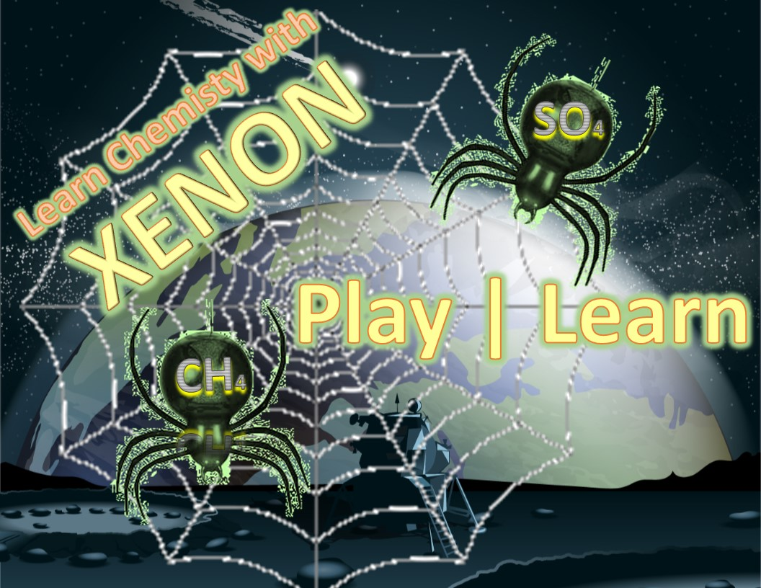

Contents

Project Overview 1

Features Implemented 1

What’s Left 2

Known Issues 2

Functionality 2

HomeScreen 2

Level 1 2

Level 2 3

Level 3 4

Level 4 4

Level 5 5

Level Selection Screen 5

GAME POSTER 6

Screencast 6

The Team 6

Laura Arevalo 6

Cat Windham 6

Charneaka Lewis 6

Magdalena Ledezma 6

Chinelo Obiamalu 6

Clients: 7

Ceniz Gunay 7

Thomas Gluick 8

Testing 8

Coverage 8

Methods 8

Results 8

Usability Testing 9

Instructions 12

Installation 12

Developer and User Documentation 12

Licensing 12

# Project Overview

A user-friendly, simple web-based game that aids chemistry students in their learning of molecular nomenclature.

# Features Implemented

The Xenamorph additions to Xenon were as follows:

* Missing level 3 was created.
* Level selection screen was implemented with allows users to skip levels.
* Testing framework was established with Nightwatch.
* Level 1 code was edited, and lines of code condensed by over fifty percent.

# What’s Left

* Master level
* Database needs to be connected to the leaderboard
* Testing all code.
* Cleaning levels 2, 4 and 5 (if desired)
* Gameplay and graphics for either level 2 or level 4 should be redone as they are almost identical.

# Known Issues

No known issues currently.

# Functionality

## Home Screen

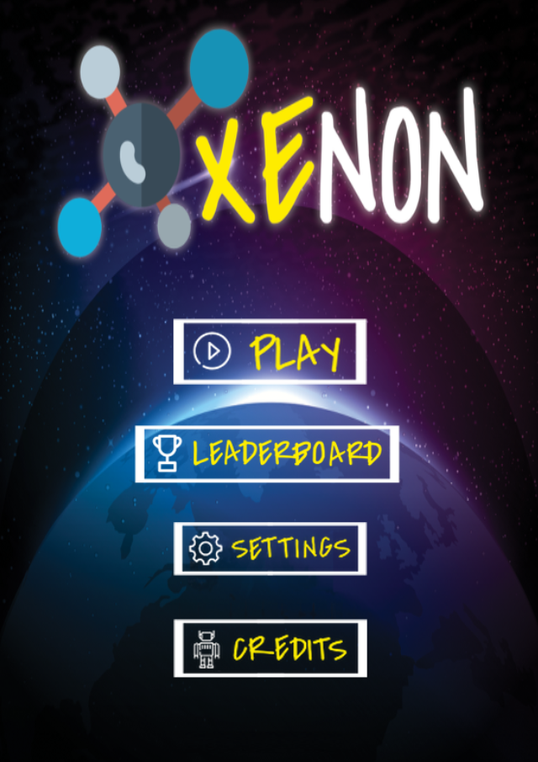

## 

## Level 1

**Player must aim the rocket and shoot at the correct asteroid before time is up.**

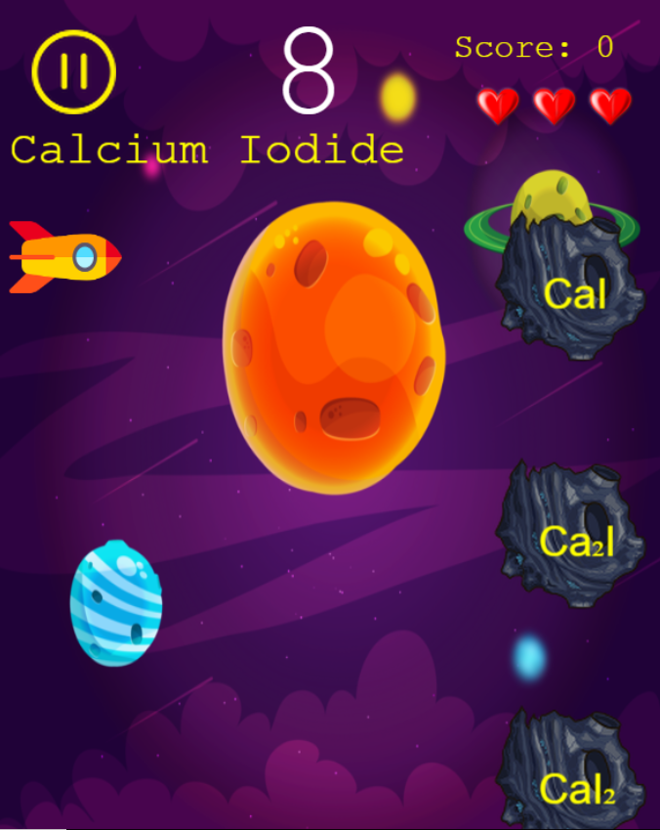

## Level 2

**Player must select the correct bubble before they hit the protruding nails.**

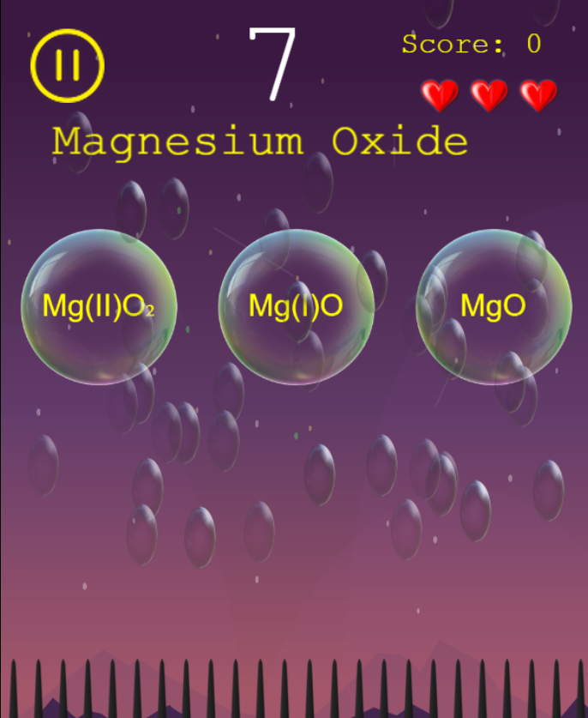

## Level 3

**Player must select the correct fly before spiders eat them.**

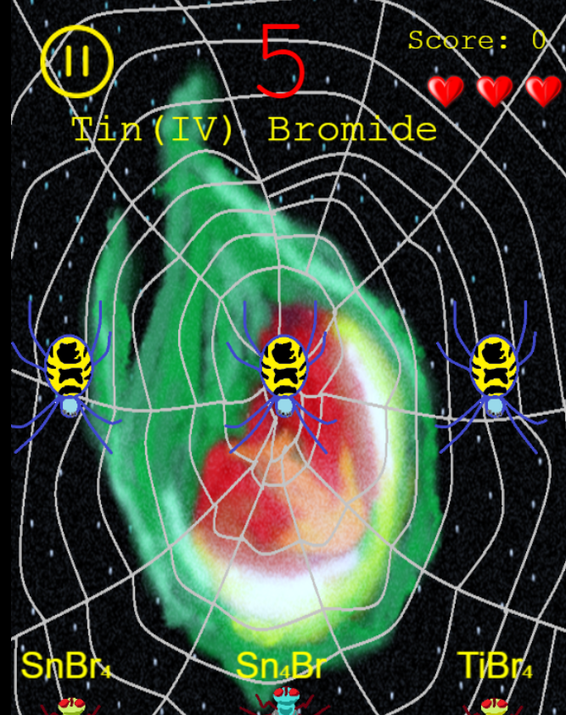

## Level 4

**The player must select the correct bubble before they fall to the ground.**

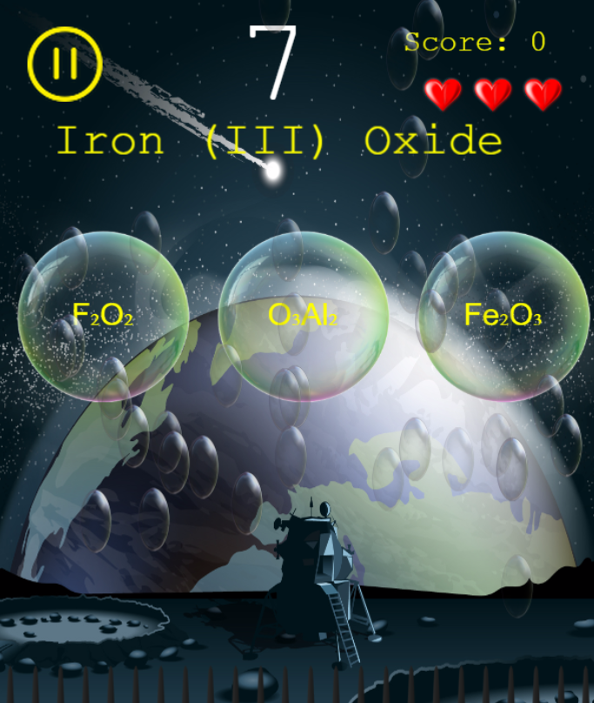

## Level 5

**The player selects the correct beaker without crushing the walking man.**

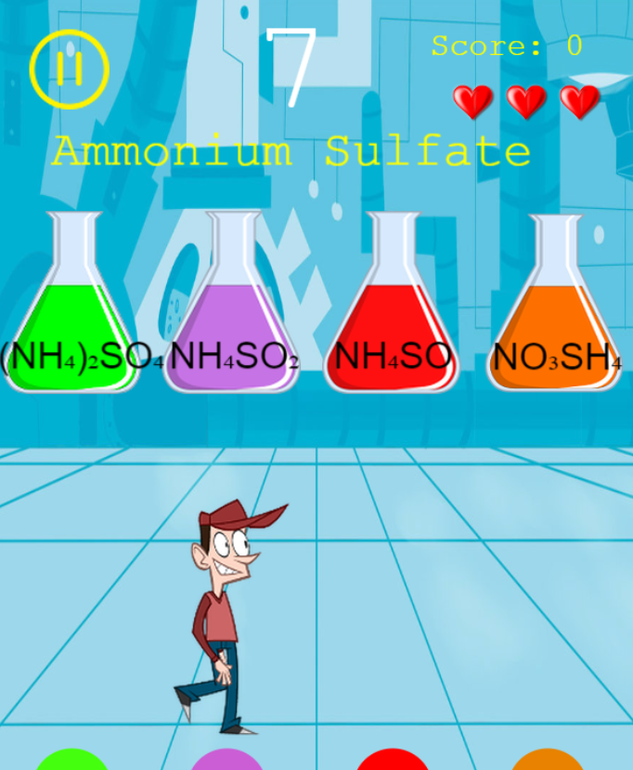

## Level Selection Screen

**User may select a level to practice at any time.**

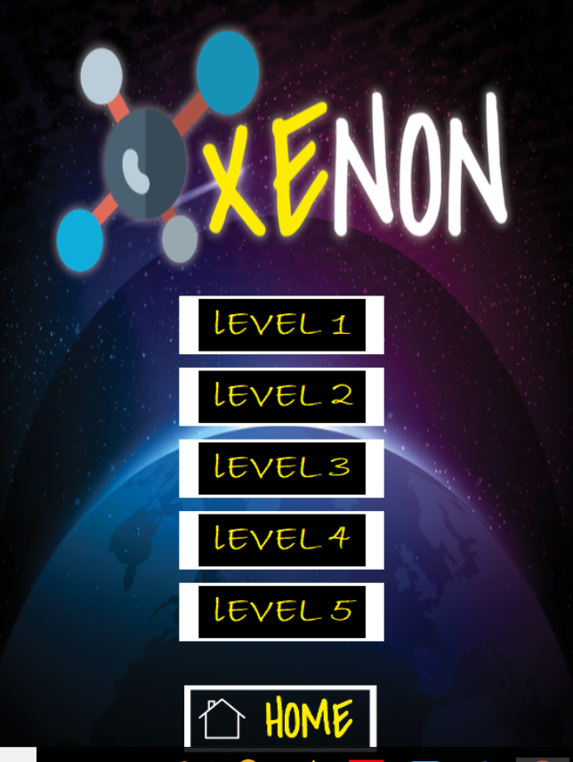

# GAME POSTER



# Screencast

You can view the screencast at this link <https://youtu.be/7Zr2xxn9mUw>

# The Team

Development Team:

Laura Arevalo **–** Laura graduates in May 2018 and is an Information Technology major with a concentration in Software Development. She is interested in full-stack web development and data analytics. She server as project lead and documentation manager for Xenon.

Cat Windham **-** Caitlin, "Cat" for short, is an ITEC major with a concentration in Software Development. Her expected graduation date is May of 2018. She is interested in augmented and virtual reality and hopes to get a career in this field.

Charneaka Lewis **-** Charneaka is originally from Bessemer, AL.  She is an IT/Software Development major in her senior year and is scheduled to graduate in December of 2018. She loves music, cooking, reading, and movies.  Her plan is to obtain a job focusing on obtaining databases or as a java developer.

Magdalena Ledezma-

Chinelo Obiamalu **–** Chinelo, Chin-Chin for short, is an Information Technology major with a concentration in Software Development. Her graduation date is May 2018, and she is interested in UI/UX design, Artificial intelligence and Augmented reality and hopes to get a job within one of these fields. She served as the UI/UX designer for Xenon.

**A group of people posing for the camera

Description generated with very high confidence**

**Left to Right – Cat, Chin-chin, Laura, Charneaka, Magdalena**

# Clients:

## Cengiz Gunay

|  |  |
| --- | --- |
| **A person wearing a white shirt and smiling at the camera  Description generated with very high confidence** | * **GGC Assistant Professor in Information Technology** * **Dr. Cengiz Gunay is a self-taught computer programmer** * **Bachelor's degree with an electronics and telecommunications focus** * **Switched to computer science and specialized in artificial intelligence and neural networks** |

## Thomas Gluick

|  |  |
| --- | --- |
| **A person wearing glasses and smiling at the camera  Description generated with very high confidence** | * **GGC assistant professor of Chemistry** * **Dr. Gluick began at the University of Texas as an assistant professor.** * **Research chemist at the Smithsonian Institute** * **Taught Biochemistry at the University of Maryland** * **Genetic Biologist at the National Institute of Health** |

# Testing

## Coverage

## Methods

## Results

# Usability Testing

The original user survey can be accessed at <https://docs.google.com/forms/d/1yEAF4xWDUnrtMdZli0H6h1rtoW4lTfCSKX7xgV2Br0Y/edit>

**Results**

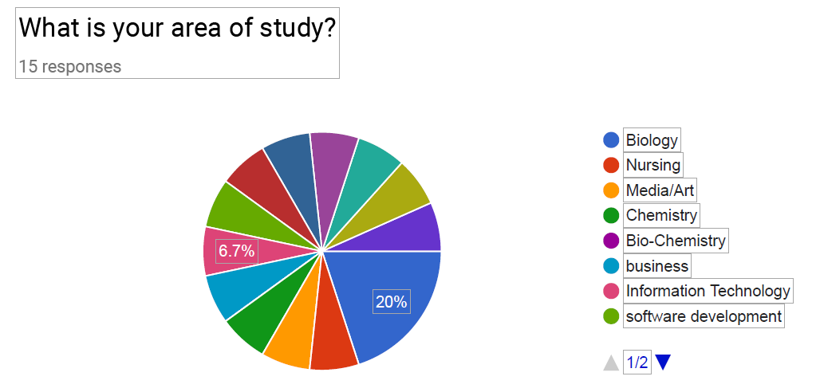

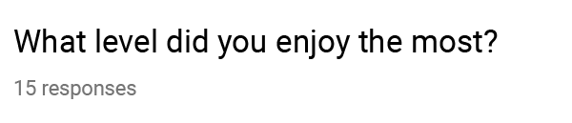

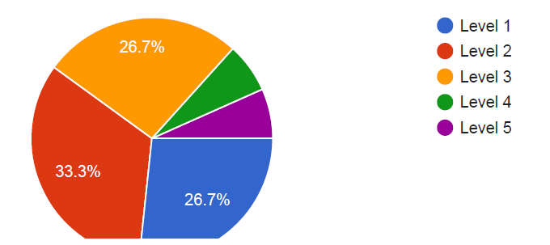

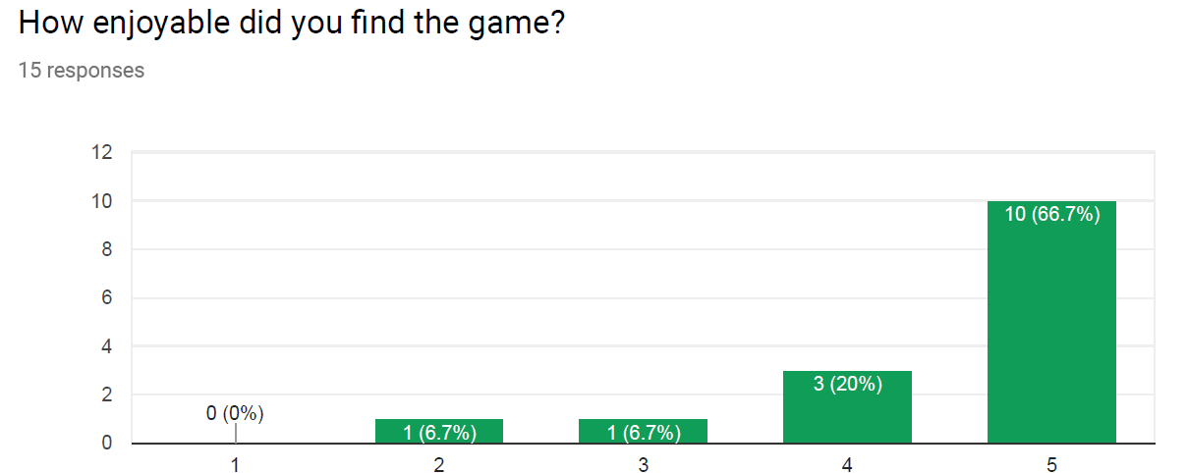 

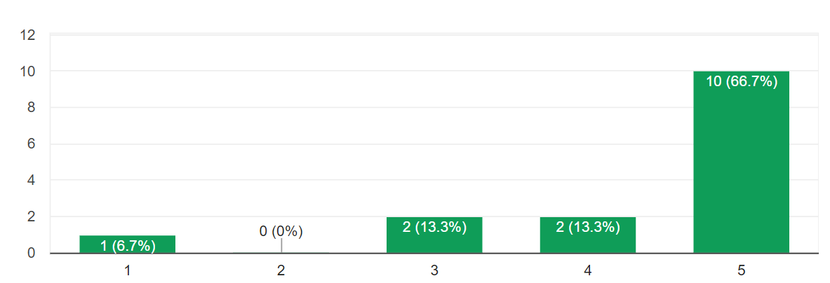

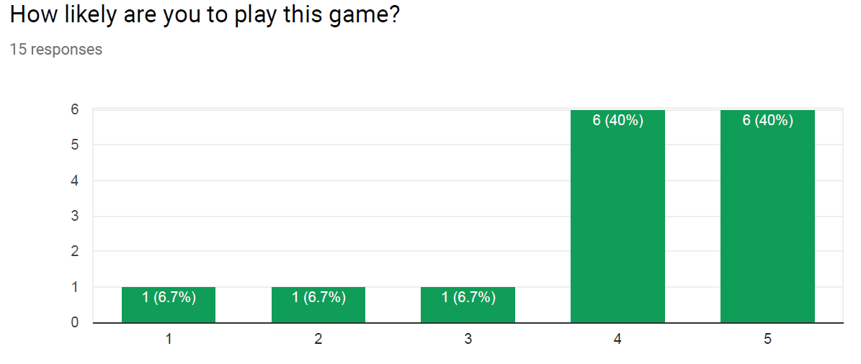 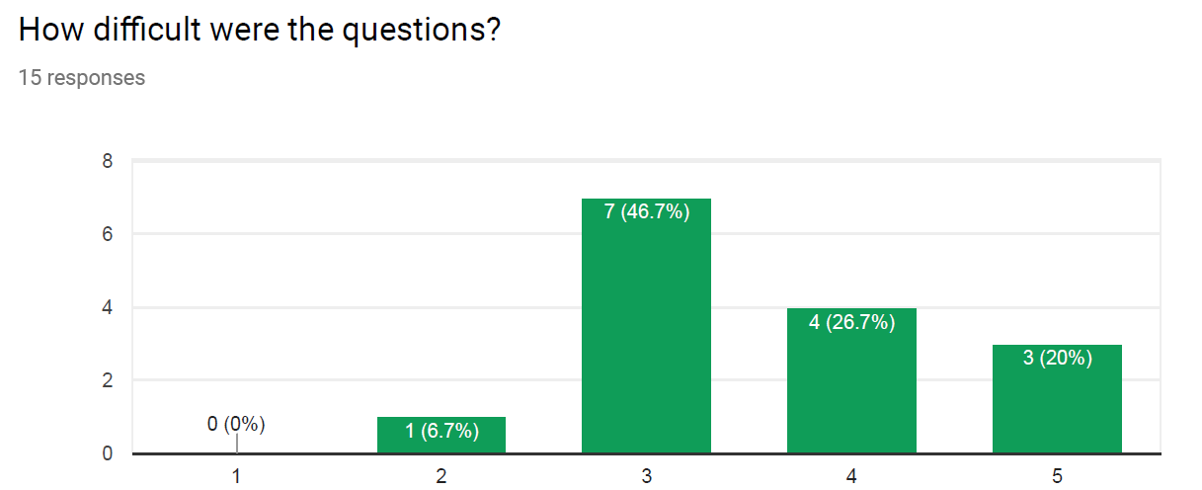

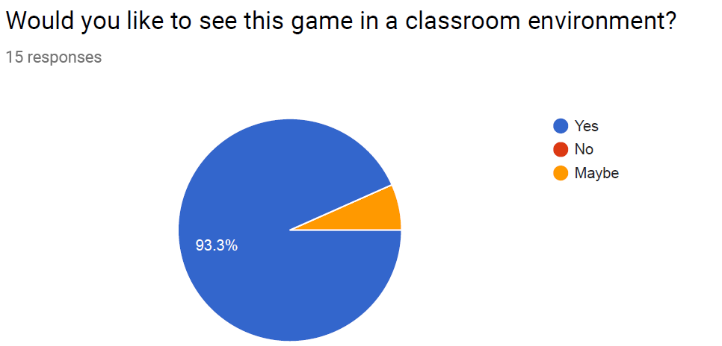



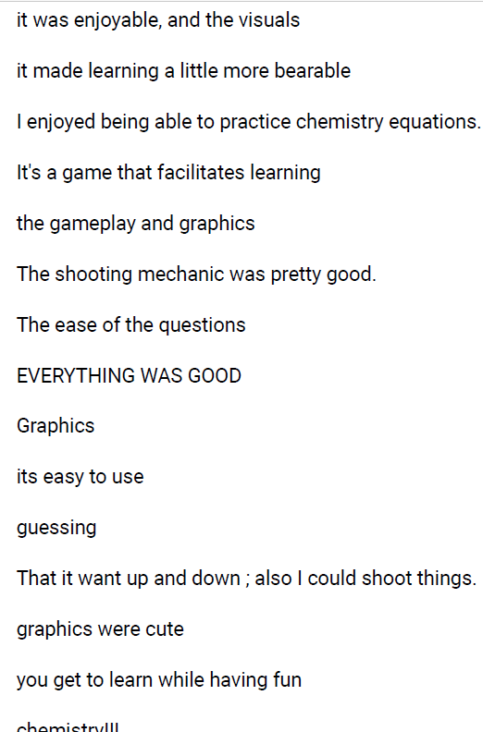  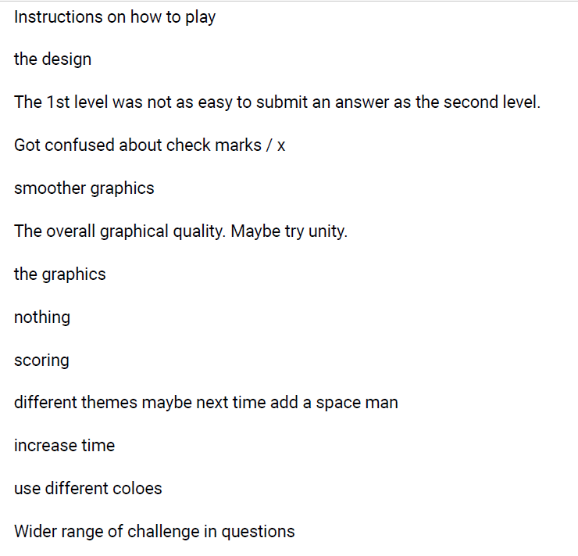 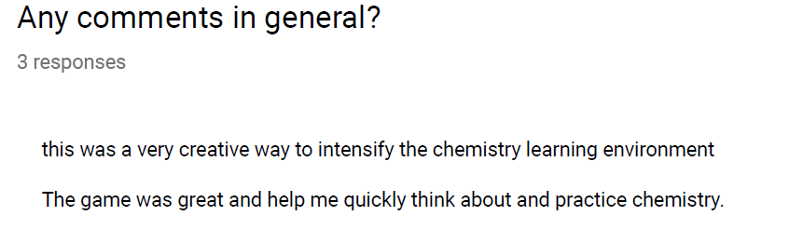

# Instructions

## Installation

* No installation required. Simply visit <https://soft-eng-practicum.github.io/xenon/>

## Developer and User Documentation

* All documentation can be found in the Xenon GitHub repository at

<https://github.com/soft-eng-practicum/xenon/tree/master/official-documentation>

# Licensing

* Licensing is under the Creative Commons Attribution-Non-Commercial 4.0 International and can be viewed at <https://github.com/soft-eng-practicum/xenon/tree/master/official-documentation/dev-docs>